# Invoice Convertor App

## Installation:

Unzip the folder

Run the setup application

Move the CSV Folder to the C:\ Drive

## Steps:

Click the Open File button

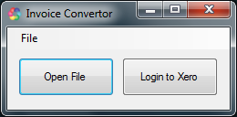

Enable the Macro

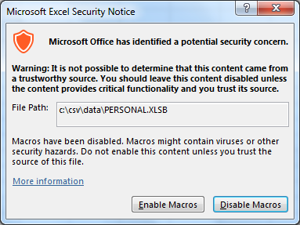

Find and Open the invoice file

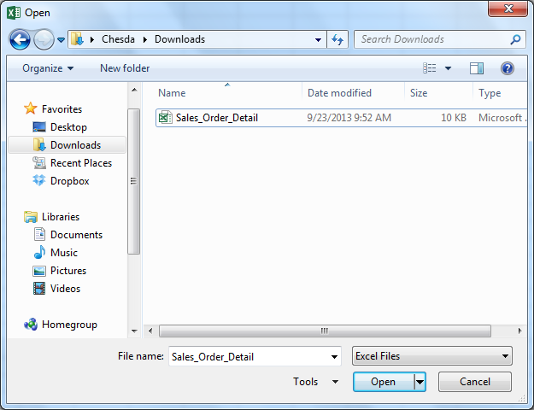

The conversion is done and the CSV file is saved to C:\CSV folder

